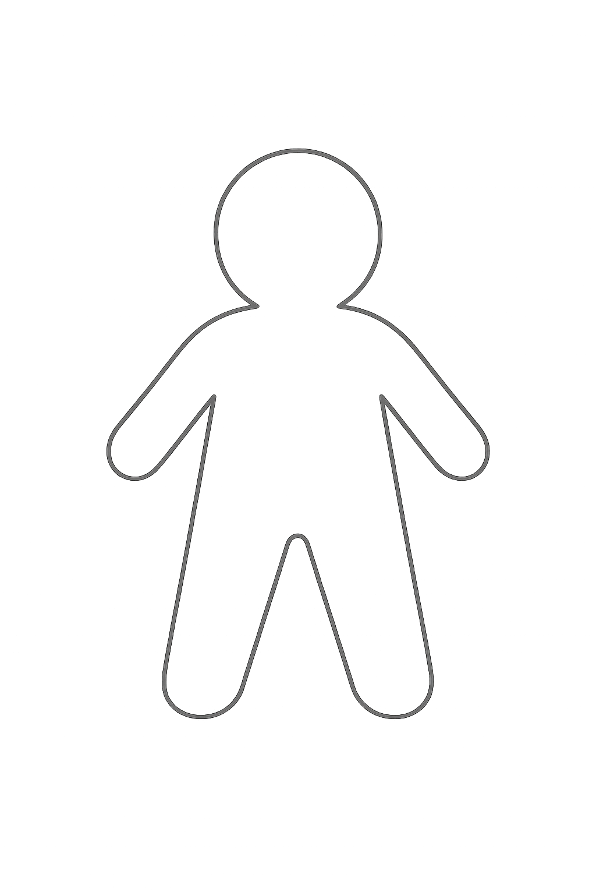**CHARACTER NAME** ____________________________________